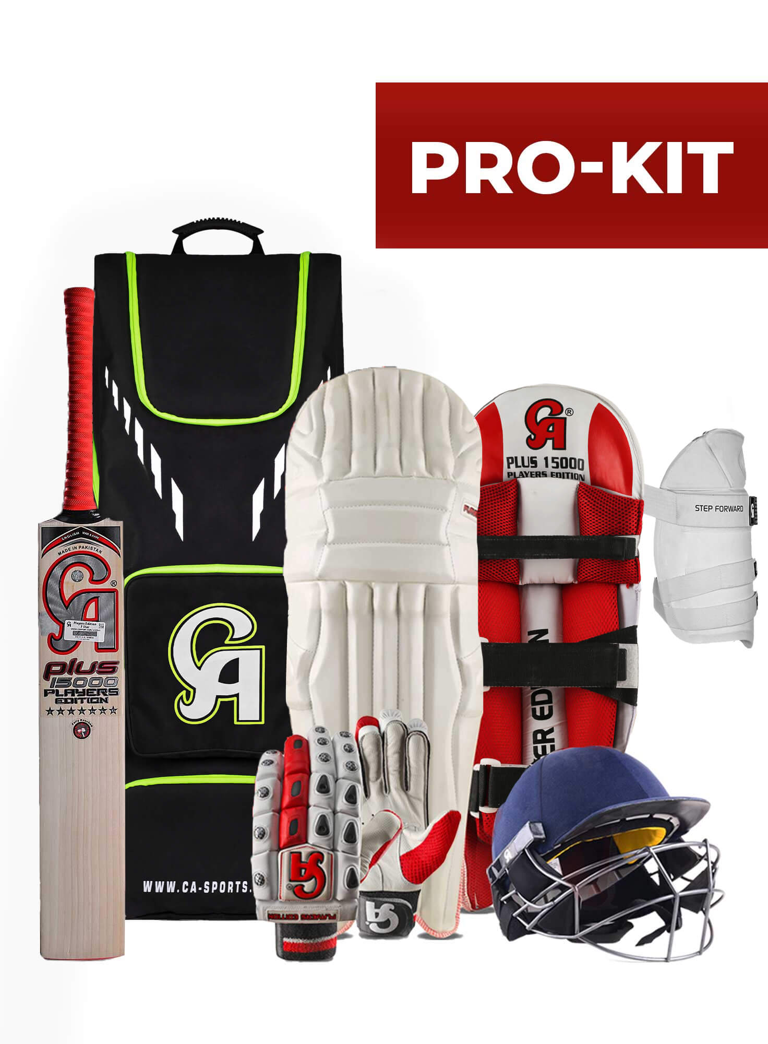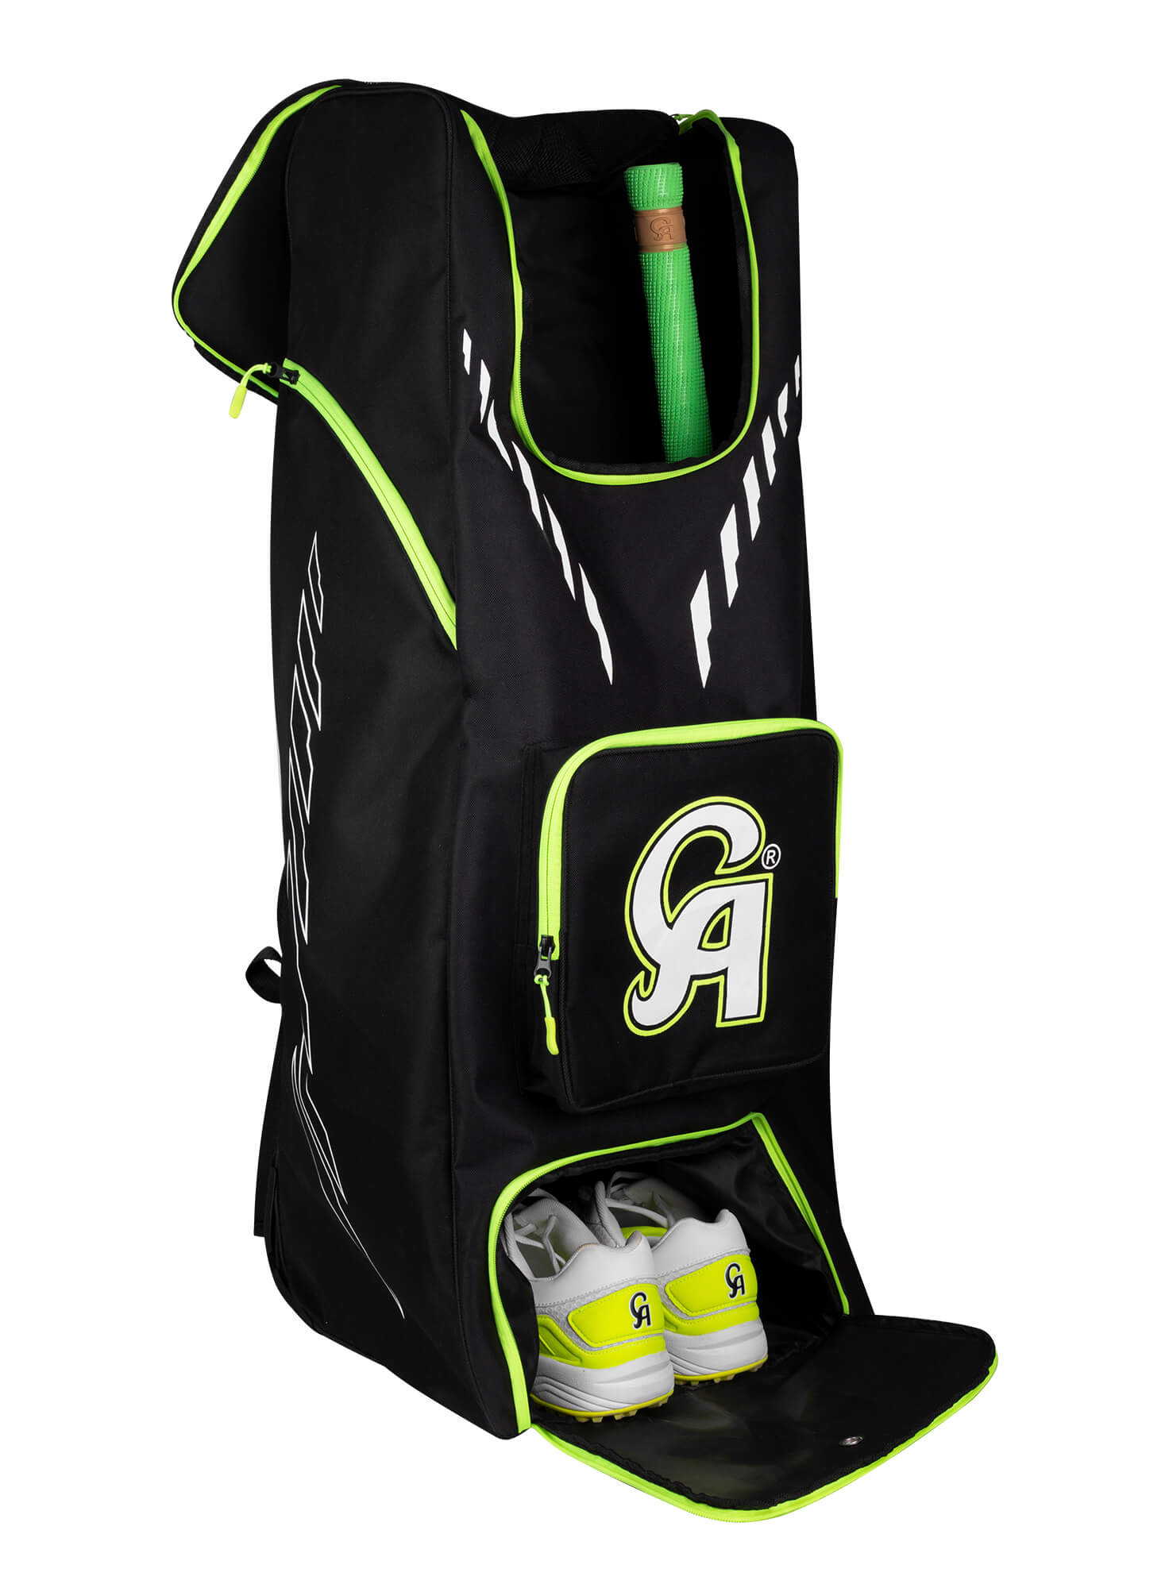

CA SPORTS PRO-KIT

6 Piece ergonomic style enormous technology jampack of a cricket kit powerline to boost up the game. Introducing the uncontaminated face elite bat flames up the morale of a player with a way better functioning on the battlefield. The thigh pad and batting pads are the compliant sources of protection with underneath padding assuring the level of comfort. Classic and modish face & velcro fashioned gloves confirm the fingers well being among the dual layer of padding on the surface of fingers. Inline the latest branding alluring the vogue with play. Head safety confirmed by the unique tech helmet level up the confidence to swing the sixes without any fear of injury. Equip all the strength of training in the enormous kit bag and go away toward the grounds. Durable and lightweight gears deal in one pack available in stock. Get in touch to reserve yours